Katya Bestpartochna

Box #58

Cairn University School of Business

CIS122 Essentials of Networking

Project #5

Project objective:

The goal of this project was to setup a dhcp server.This is what gives out IP addresses in a network

Equipment used:

|  |  |  |  |  |
| --- | --- | --- | --- | --- |
| Equipment Description | Vendor | Vendor Item # | Retail price | Actual price (if known) |
| DHCP server | Newegg | 9SIABMK5D72767 | $36.99 |  |

Detailed list of software and operating platforms used, including version numbers and licensing requirements:

USR-TCP232-302 Serial RS232 to Ethernet TCP IP Server DHCP/DNS

Network diagram:

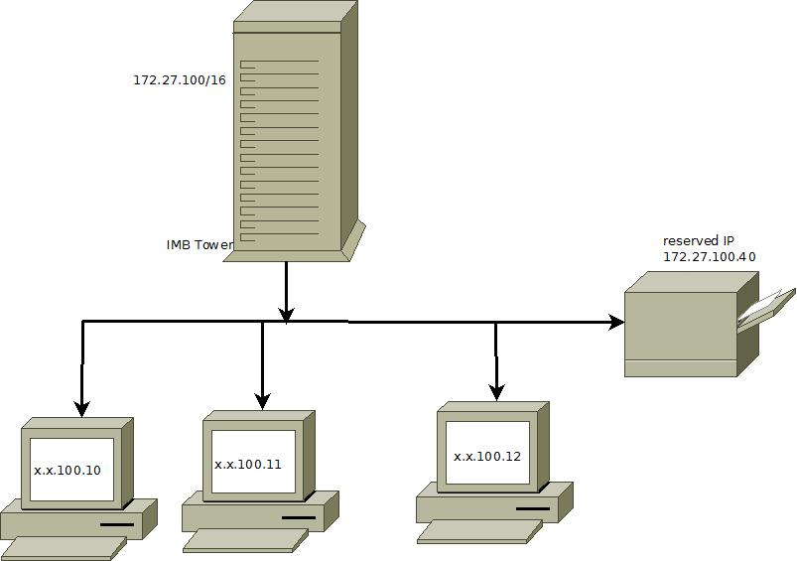

Configurations:

1. Decide what range of IP addresses you would like to use.
2. Set the IP address of your computer to 192.168.0.2 with a subnet mask of 255.255.255.0 (an address in the same subnet as the addresses in the pool, but not an address in the pool itself!)
3. Download tftpd32 from <http://tftpd32.jounin.net/>
4. Unzip the file to your computer and run tftpd32.exe.
5. Click Settings.
6. Select the DHCP tab in the Settings window.
7. Set the "IP pool starting address" to the address you want the first computer to use DHCP to have. (192.168.0.100 if you're not sure!)
8. Set the "Size of pool" to a little more than the number of computers and devices you think you'll need on your LAN.
9. Leave the "Boot File" field blank
10. Enter the IP address you gave the computer (192.168.0.2) in field "Def. Router (Opt 3)
11. If you have a DNS server on your network, or **one accessible** to the machines on your network, enter it's IP address in the "WINS/DNS Server" box. If you don't, or don't know what it means, leave it blank.
12. Set "Mask" to your subnet mask. If you don't know what that is, follow my addressing scheme and set it to 255.255.255.0
13. Leave the "Domain Name" and "Additional Option" boxes as they are.